Web page for the Abdominal Aortic Aneurysm Screening Programme
Abdominal Aortic Aneurysm Screening
(otherwise known as AAA Screening)

The NHS Abdominal Aortic Aneurysm (AAA) Screening Programme’s main aim is to reduce the number of deaths from ruptured AAAs.

About the condition:

An AAA is a weakening and stretching of the main blood vessel (aorta) in the abdominal (tummy) area. The aorta supplies blood to the body.

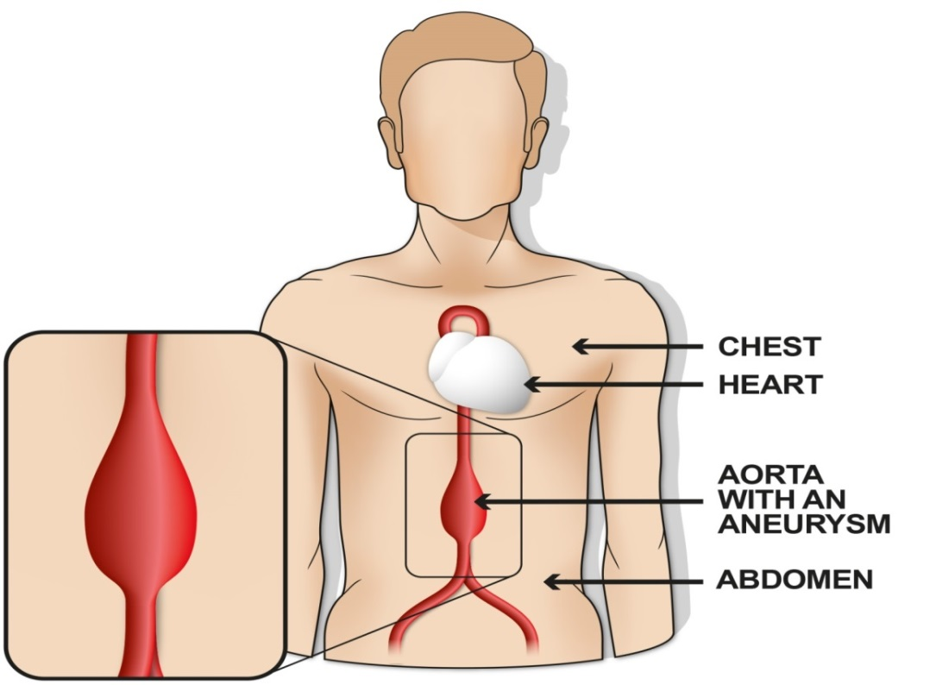

Image courtesy Public Health England

If you have an AAA there is a risk that it may split or tear (rupture).

An AAA does not usually present with any symptoms, therefore, people do not know they have one.

One of the main risk factors is being male. This includes transgender women who were assigned (born) male at birth. The risk increases with age and can also increase if you:

- smoke
- have high blood pressure
- have a close family history of this condition

The test

An ultrasound scan is used to test for an AAA. This is similar to that used during pregnancy to check on the baby. This takes, on average, approximately 10 minutes and results are usually given straight away.

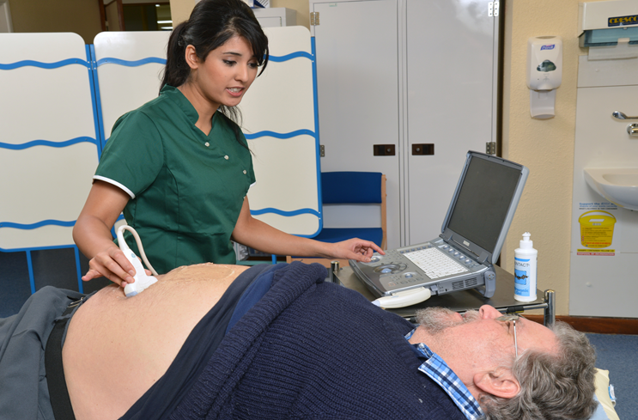

Image courtesy of Public Health England
Who is eligible for screening?

- Men who are registered with a GP as male, are in their 65th year and older and have not previously been screened.

- People assigned male at birth, are registered with their GP as female in their 65th year and older and have not previously been screened.

- People assigned male at birth, are registered with their GP as non-binary in their 65th year and older and have not previously been screened.

People who have had an operation to repair an AAA are not eligible for screening. Therefore, if you have had a repair for an AAA and have been invited for screening, please inform your local screening programme – see the ‘Who to contact’ section.

How to access screening?

Invitation letters are automatically sent out to:
- Men registered with their GP as male who are in their 65th year.

People who will need to contact their local AAA screening programme to request to be screened:

- Men registered with their GP as male who are over 65 years of age – see the ‘Who to contact’ section.

- People assigned male at birth who are registered with their GP as female or non-binary and who are in their 65th year and older – see the ‘Who to contact’ section.

Within the Nottinghamshire AAA screening programme clinics are held mainly in community venues throughout the local area. Please contact the Nottinghamshire screening programme to find out where your local clinic is.

Who to contact:

The Nottinghamshire AAA screening programme office is open 9am – 5pm and is based at Queen’s Medical Centre, Nottingham. Contact details are:

- Tel: 0115 9249924, ext. 62394 or 82378 – if you are leaving a voicemail message please include a forwarding telephone number.

- Email: NUHNT.AAAScreeningProgramme@nhs.net

- Address: The Nottinghamshire AAA screening Programme, Nottingham University Hospitals NHS Trust, Queen’s Medical Centre, F11 Curie Court, Derby Road, Nottingham. NG7 2UH

Further information can be found at:

- Nottinghamshire AAA Screening Programme – contact details as above

- NHS Abdominal Aortic Aneurysm Screening Programme website on https://www.nhs.uk/conditions/abdominal-aortic-aneurysm-screening/

- NHS AAA Screening Programme information on GOV.UK

